**Avon Catalog Management System**

FINAL PROJECT

In the Subject  
of

**IT101 – Introduction to Programming**

By

**Bronia, Irvin**

**Bombales, Rena**

**Daria, Jomel**

**Floresca, Karl**

**Molleno, Vincent**

**Ocol, John Michael**

**Samson, Rogie**

**San Juan, Regie**

**Valencia, Dexter**

Members

**Company Profile**

AVON is a leading global beauty company that has been in the industry for over 135 years. It is a company that stands for beauty, innovation, optimism, and above all, women. It is also one of the world’s largest direct sellers, with more than 6 million active independent Avon Sales Representatives who provide millions of customers worldwide with trusted, personal beauty advice and products.

AVON offers a wide range of skincare, color cosmetics, fragrance, personal care, and health and wellness products featuring brands such as ANEW, Skin So Soft, belif, CHI, and The Face Shop, as well as home essentials, fashion and accessories. It also creates products that embrace the hottest trends and cutting-edge technology, alongside everyday essentials that are the staples of the beauty kit.

AVON is more than a beauty company; it is a global movement that uses the power of beauty to transform women’s lives for the better. It is committed to positive social and environmental impact through its support for causes that matter to women and through how it does business. It speaks out about breast cancer and gender-based violence, raising awareness, explaining how to take action and fundraising for relevant organizations. It also provides opportunities for women around the world to earn and learn, supporting them to build their own businesses and achieve economic freedom.

**FOUNDER**

AVON was founded in 1886 by David H. McConnell in New York City, who wanted to provide an opportunity for women to earn and learn. He started by selling perfumes door-to-door and soon recruited his first female sales representative, Mrs. P.F.E. Albee. Since then, AVON has grown to become a global company with nearly $11 billion in annual revenue. It has its headquarters in New York, NY and operates in over 100 countries.

**MISSION**

To improve the lives of women globally by providing them with opportunities, products, and support for their well-being and happiness.

**VISION**

To be the company that best understands and satisfies the product, service and self-fulfillment needs of women – globally.

**VALUES**

To uphold the principles of BIRTH, which stand for Belief, Integrity, respect, Trust, and Humility. To also embrace the values of Transparency & Integrity, Teamwork & Winning, Speed & Innovation, Fun & Passionate, and Diversity & Inclusion.

**SLOGAN**

*“Watch Me Now”*

It reflects the spirit of empowerment, confidence, and transformation.

**Business Case**

|  |  |  |  |
| --- | --- | --- | --- |
| BUSINESS CASE | | | |
| Project Name | AVON Products Catalog | | |
| Project Sponsor | AVON | Project Manager | Rogie Samson (Team Kahit Ano) |
| Contributions to Business Strategy | What customers need is information about the products. While they can use the traditional magazine to find their desired product, it takes a long time, and there's even a chance they might miss it, or the product is in another magazine, and the company loses sales because of this. Our project introduces a fully digitalized catalog that shows all the necessary information in clean form. It also allows searches by name, which guarantees that customers will find whatever product they want. | | |
| Options Considered | Options considered include:   1. Table of contents in the hard print magazines. 2. Remind customers to refer to other magazines. 3. A digital Products Catalog(selected) | | |
| Benefits | 1. Increased Sales – A summary of products makes it easier for customers to decide ensuring more sales. 2. More accurate information presented – The digital catalog allows quick catalog updates ensuring the product information is up to date. | | |
| Timescales | Initial analysis shows that the development of the digital catalog will take approximately 1 month. | | |
| Risks | The biggest risk the digital catalog faces is an error to the code and improper maintenance. | | |

**Project Task Distribution**

|  |  |
| --- | --- |
| Team Member | Task |
| **Bronia, Irvin** | **Business Case** |
| **Bombales, Rena** | **Sample Items** |
| **Daria, Jomel** | **Company Profile** |
| **Floresca, Karl** | **PDF Generation** |
| **Molleno, Vincent** | **Readme Text File** |
| **Ocol, John Michael** | **Company Profile** |
| **Samson, Rogie** | **Designer, Programmer** |
| **San Juan, Regie** | **Business Flow** |
| **Valencia, Dexter** | **Company Profile** |

**Mock Up**

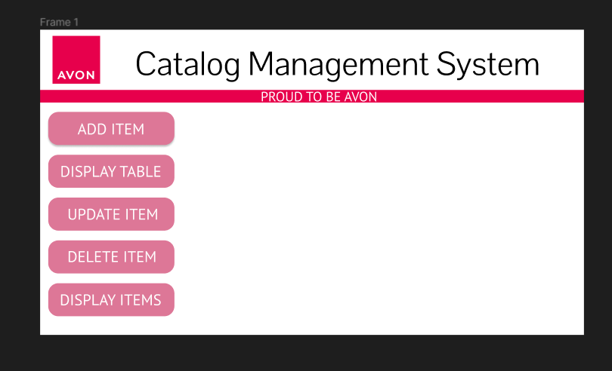

**Add item frame**

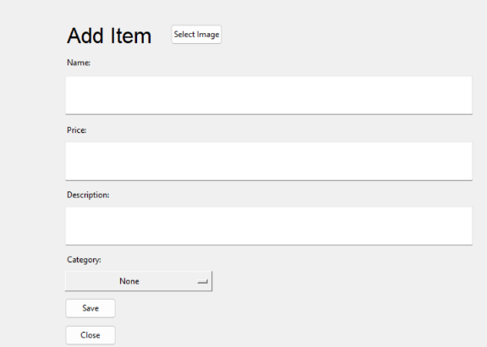

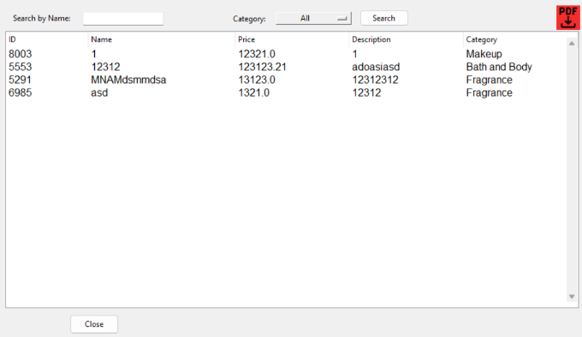

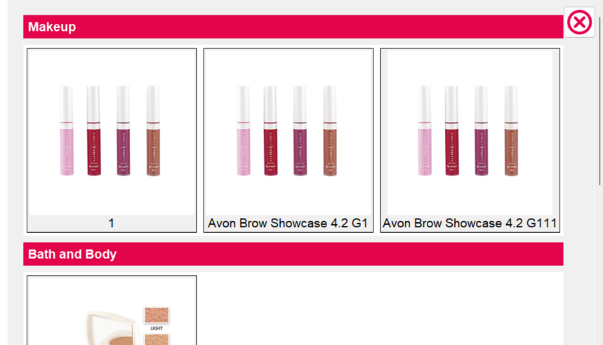

**Main UI**

**Display Table frame**

**Update item frame**

**Delete item frame**

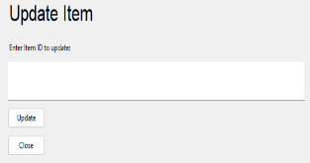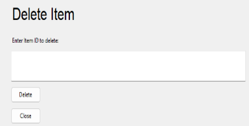

**Display item frame**

**Business Flow**

